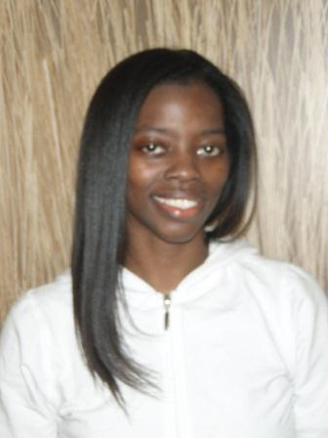

***718-774-7679 (home) 347-853-1290 (cell)***

***height: 5’4” eyes: brown hair: black***

***36-30-39 size:10 shoes: 8 Shirt: M***

***NO TATTOOS NYC LOCAL HIRE***

***Kimmy@KimberleyGayleThomas.com***

[**http://www.KimberleyGayleThomas.com**](http://www.KimberleyGayleThomas.com)

**https://resumes.actorsaccess.com/KimberleyGayleThomas**

[**http://www.imdb.com/name/nm5798337/**](http://www.imdb.com/name/nm5798337/)

[**https://www.castingnetworks.com/kimberleygaylethomas**](https://www.castingnetworks.com/kimberleygaylethomas)

[**https://www.backstage.com/kimberleygaylethomas/**](https://www.backstage.com/kimberleygaylethomas/)

Education: BA (Theater) - Brooklyn College, June ‘99

# FILM

Expired Lead Doug Inbger

Class Trip Lead  Sarah Gyllenstier

Wicked Hour Supporting Actress Polina Bittau

# Theater

Barefoot in the Park Corie Bratter Brooklyn College

The Prisoner of Second Avenue Edna Edison Brooklyn College

Oliver Mrs. Sowerberry Cornerstone Baptist Church

# Commercials

##### Available upon request

# Training

Commerical Levels 1-5 Michael Pointer Hey, I Saw Your Commerical

Commercial Intensive David Bellantoni, CD, Beth Melsky Casting Scott Powers Studio

Meisner Level 2 Jessica Houde Houde School of Acting

VoiceOver Intensive Lisa Fischoff, CD, Broadcasters Actors Connection

Scene Study Ted Brunetti, producer Actors Connection

On Camera Commercial Barry Shapiro of Herman & Lipson Casting ActorsConnection

Accents for the 21st Century Actor Paul Liberti Actors Connection

Commercial Voice Overs Paul Liberti Actors Connection

Acting for Film &TV Lorrie Odom Actors Connection

On Camera Commercials Angela Montelbano Actors Connection

Law of Attraction for Actors Colleen Kahl Actors Connection

Improv Maimonides FACES Maimonides FACES

Skits, monologues, scenes Lynette Sheldon Lynette Sheldon Actors Studio

# Education

Scene Study Rose Bonczek & Thomas Bullard Brooklyn College

Improv Rose Bonczek & Thomas Bullard Brooklyn College

Monologues Rose Bonczek Brooklyn College

Diction & Dialects Charlotte Fleck Brooklyn College

Movement Karen Barracuda Brooklyn College

Physical Comedy & Stunts Rose Bonczek Brooklyn College

# Special Skills, Interests & Hobbies:

Passport expires May 2034, Improv, Dance, Singing (Soprano), Sports, Yoga, Pilates, Pets, Singing, Rollerblading, Volleyball, Cooking, Karate, Gymnastics, Knitting, Crocheting, Physical Comedy, Stunts, Accents, First Aid, Computer Literate, Ice Skating & more